**WEEK 4  
1. SPRING REST HANDSON**

**EXERCISE 1: Create a Spring Web Project using Maven**

Command Prompt – after mvn clean package:

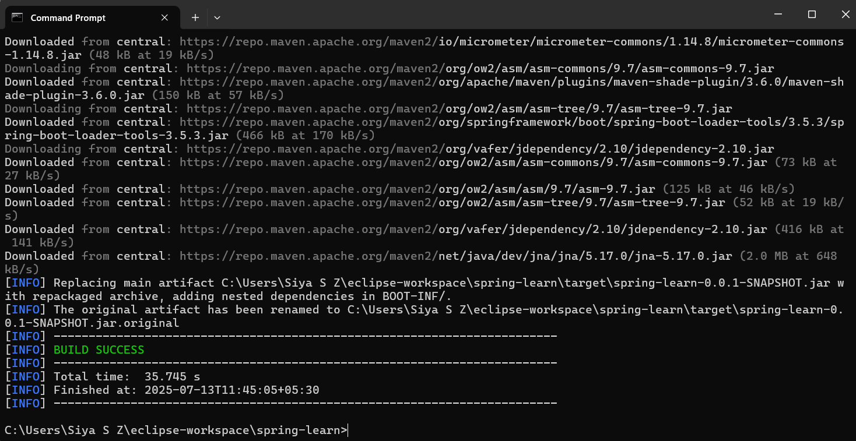

Running SpringLearnApplication:

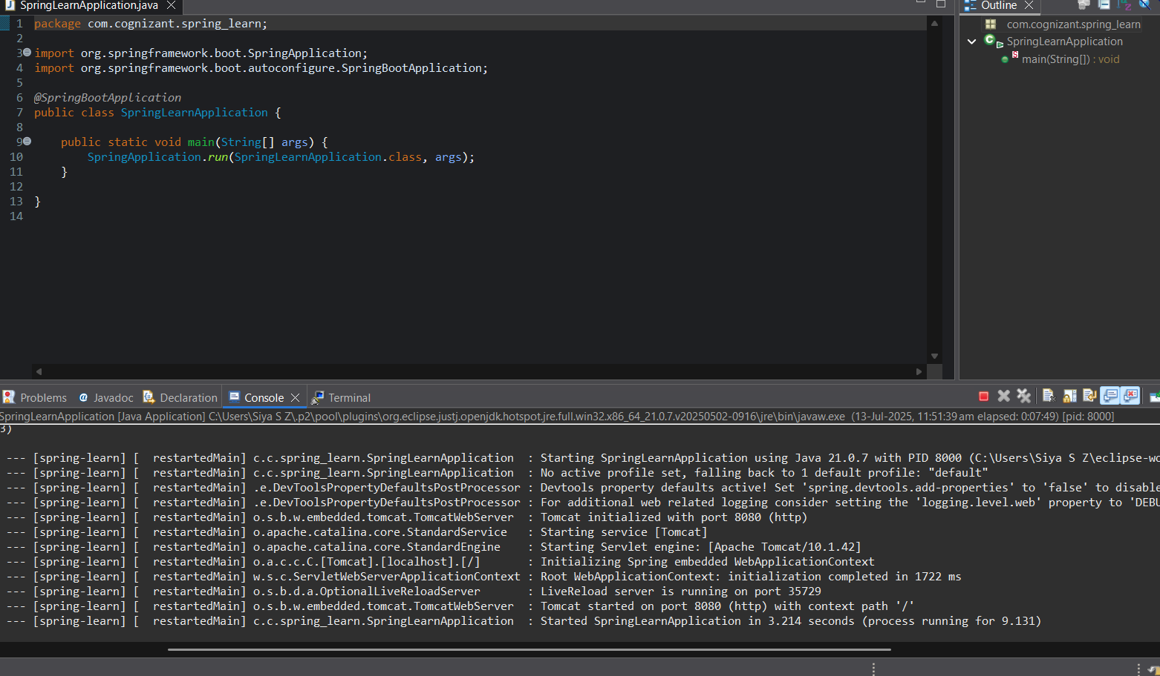

Dependency Hierarchy:

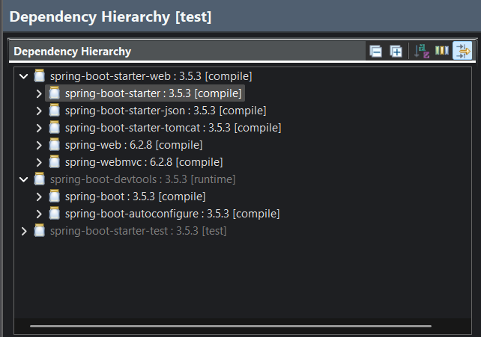

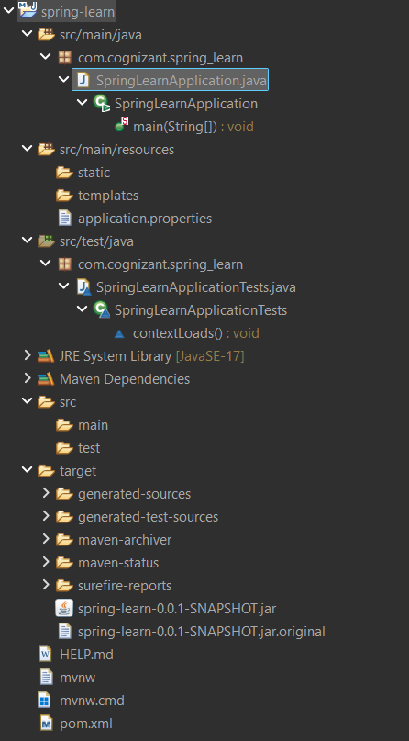

**EXERCISE 2: Spring Core – Load Country from Spring Configuration XML**

**SpringLearnApplication.java:**package com.cognizant.spring_learn;

import org.slf4j.Logger;

import org.slf4j.LoggerFactory;

import org.springframework.context.ApplicationContext;

import org.springframework.context.support.ClassPathXmlApplicationContext;

public class SpringLearnApplication {

private static final Logger ***LOGGER*** = LoggerFactory.*getLogger*(SpringLearnApplication.class);

public static void main(String[] args) {

***LOGGER***.info("START");

***LOGGER***.debug("TEST: Calling displayCountry()");

*displayCountry*();

***LOGGER***.debug("TEST: Finished calling displayCountry()");

*displayCountry*(); // ✅ Make sure this line is present

***LOGGER***.info("END");

}

public static void displayCountry() {

ApplicationContext context = new ClassPathXmlApplicationContext("country.xml");

Country country = (Country) context.getBean("country", Country.class);

***LOGGER***.debug("Country : {}", country.toString());

}

}

**Country.java:**package com.cognizant.spring_learn;

import org.slf4j.Logger;

import org.slf4j.LoggerFactory;

public class Country {

private static final Logger ***LOGGER*** = LoggerFactory.*getLogger*(Country.class);

private String code;

private String name;

// Constructor

public Country() {

***LOGGER***.debug("Inside Country Constructor.");

}

// Getter for code

public String getCode() {

***LOGGER***.debug("Inside getCode()");

return code;

}

// Setter for code

public void setCode(String code) {

***LOGGER***.debug("Inside setCode()");

this.code = code;

}

// Getter for name

public String getName() {

***LOGGER***.debug("Inside getName()");

return name;

}

// Setter for name

public void setName(String name) {

***LOGGER***.debug("Inside setName()");

this.name = name;

}

*@Override*

public String toString() {

return "Country [code=" + code + ", name=" + name + "]";

}

}

**country.xml:**

<?xml version="1.0" encoding="UTF-8"?>

<beans xmlns="http://www.springframework.org/schema/beans"

xmlns:xsi="http://www.w3.org/2001/XMLSchema-instance"

xsi:schemaLocation="http://www.springframework.org/schema/beans

http://www.springframework.org/schema/beans/spring-beans.xsd">

<bean id="country" class="com.cognizant.spring_learn.Country">

<property name="code" value="IN"/>

<property name="name" value="India"/>

</bean>

</beans>  
  
**RESULT:**

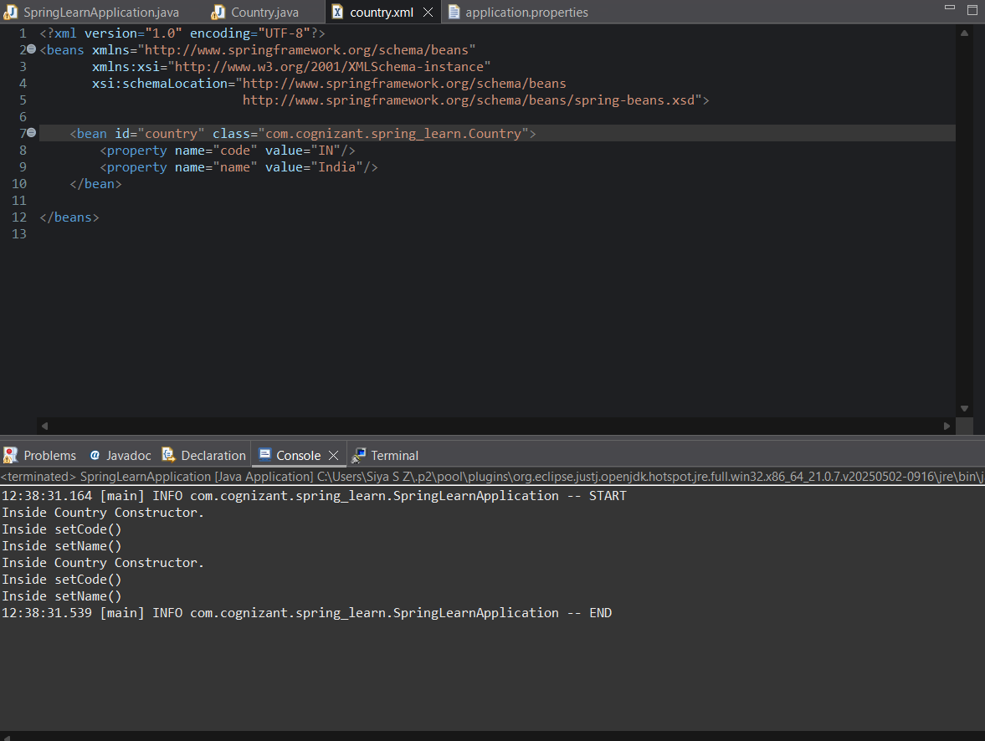

**2. SPRING REST HANDSON**

**EXERCISE 3: Hello World RESTful Web Service  
HelloContoller.java:**

package com.cognizant.spring_learn.controller;

import org.slf4j.Logger;

import org.slf4j.LoggerFactory;

import org.springframework.web.bind.annotation.GetMapping;

import org.springframework.web.bind.annotation.RestController;

*@RestController*

public class HelloController {

private static final Logger ***LOGGER*** = LoggerFactory.*getLogger*(HelloController.class);

*@GetMapping*("/hello")

public String sayHello() {

***LOGGER***.info("START: sayHello()");

String message = "Hello World!!";

***LOGGER***.info("END: sayHello()");

return message;

}

}

**SpringLearnApplication.java:** package com.cognizant.spring_learn;

import org.springframework.boot.SpringApplication;

import org.springframework.boot.autoconfigure.SpringBootApplication;

import org.slf4j.Logger;

import org.slf4j.LoggerFactory;

*@SpringBootApplication*

public class SpringLearnApplication {

private static final Logger ***LOGGER*** = LoggerFactory.*getLogger*(SpringLearnApplication.class);

public static void main(String[] args) {

***LOGGER***.debug("START");

SpringApplication.*run*(SpringLearnApplication.class, args);

***LOGGER***.debug("END");

}

public static void displayCountry() {

ApplicationContext context = new ClassPathXmlApplicationContext("country.xml");

Country country = (Country) context.getBean("country", Country.class);

***LOGGER***.debug("Country : {}", country.toString());

}

}

**application.properties:**spring.application.name=spring-learn

logging.level.root=DEBUG

logging.level.com.cognizant.spring_learn=DEBUG

server.port=8083

**RESULT:**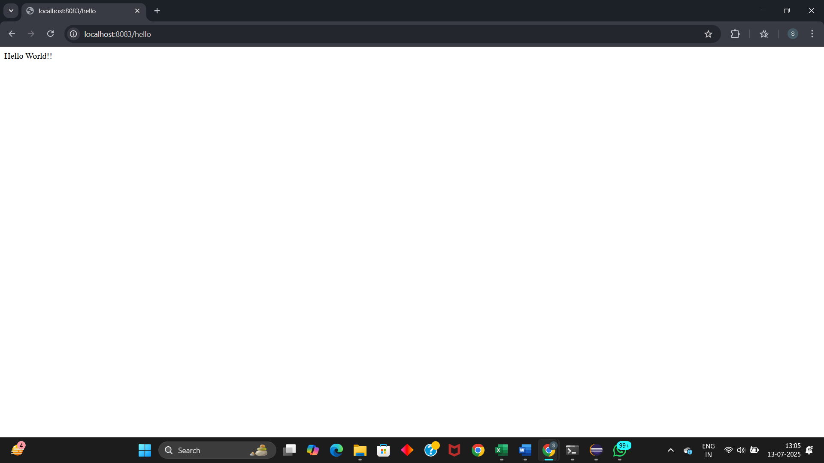

**EXERCISE 4: REST - Country Web Service**

**SpringLearnApplication.java:**package com.cognizant.spring_learn;

import org.springframework.boot.SpringApplication;

import org.springframework.boot.autoconfigure.SpringBootApplication;

import org.springframework.context.ApplicationContext;

import org.springframework.context.support.ClassPathXmlApplicationContext;

import org.slf4j.Logger;

import org.slf4j.LoggerFactory;

*@SpringBootApplication*

public class SpringLearnApplication {

private static final Logger ***LOGGER*** = LoggerFactory.*getLogger*(SpringLearnApplication.class);

public static void main(String[] args) {

***LOGGER***.debug("START");

SpringApplication.*run*(SpringLearnApplication.class, args);

// Optional: Call this only if you want to test loading XML bean directly

// displayCountry();

***LOGGER***.debug("END");

}

public static void displayCountry() {

ApplicationContext context = new ClassPathXmlApplicationContext("country.xml");

Country country = context.getBean("country", Country.class);

***LOGGER***.debug("Country : {}", country.toString());

}

}

**CountryController.java:**package com.cognizant.spring_learn.controller;

import com.cognizant.spring_learn.Country;

import org.slf4j.Logger;

import org.slf4j.LoggerFactory;

import org.springframework.context.ApplicationContext;

import org.springframework.context.support.ClassPathXmlApplicationContext;

import org.springframework.web.bind.annotation.RequestMapping;

import org.springframework.web.bind.annotation.RestController;

*@RestController*

public class CountryController {

private static final Logger ***LOGGER*** = LoggerFactory.*getLogger*(CountryController.class);

*@RequestMapping*("/country")

public Country getCountryIndia() {

***LOGGER***.debug("START: getCountryIndia()");

ApplicationContext context = new ClassPathXmlApplicationContext("country.xml");

Country country = (Country) context.getBean("country", Country.class);

***LOGGER***.debug("END: getCountryIndia()");

return country;

}

}

**country.xml:**<?xml version="1.0" encoding="UTF-8"?>

<beans xmlns="http://www.springframework.org/schema/beans"

xmlns:xsi="http://www.w3.org/2001/XMLSchema-instance"

xsi:schemaLocation="http://www.springframework.org/schema/beans

http://www.springframework.org/schema/beans/spring-beans.xsd">

<bean id="country" class="com.cognizant.spring_learn.Country">

<property name="code" value="IN"/>

<property name="name" value="India"/>

</bean>

</beans>

**RESULT:**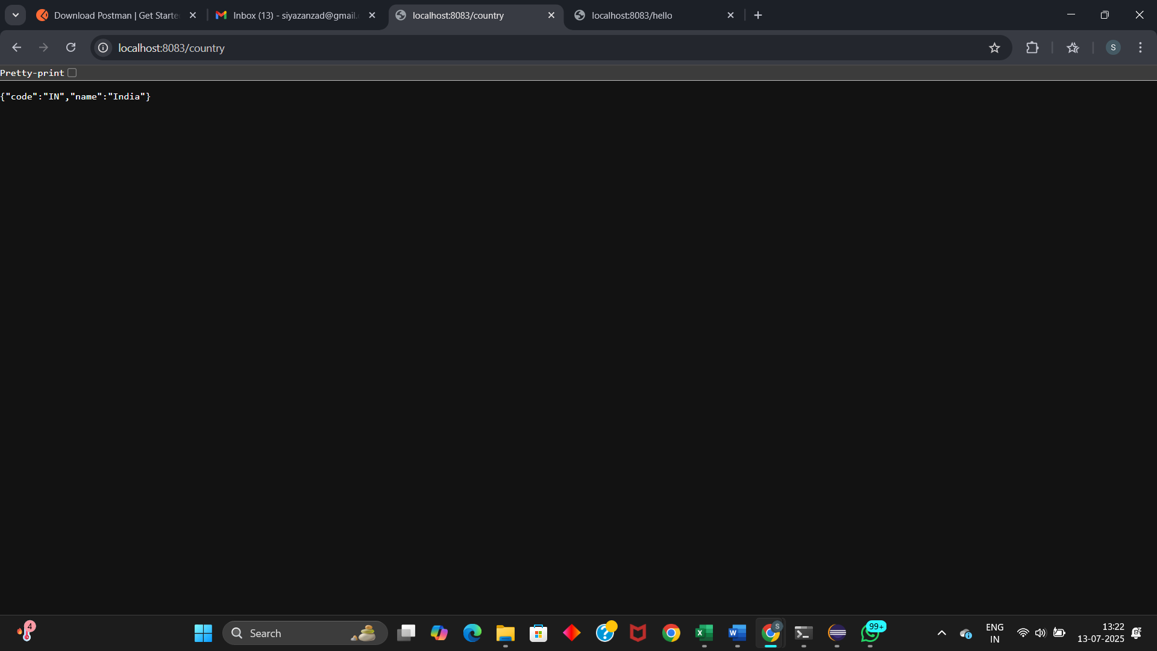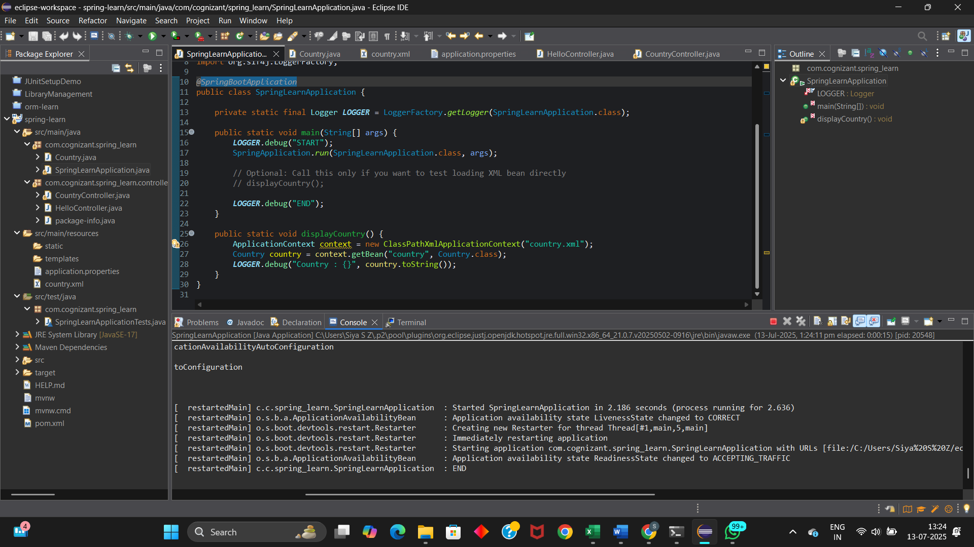

**EXERCISE 5: REST - Get country based on country code**

**SpringLearnApplication.java:**package com.cognizant.spring_learn;

import org.springframework.boot.SpringApplication;

import org.springframework.boot.autoconfigure.SpringBootApplication;

import org.springframework.context.ApplicationContext;

import org.springframework.context.support.ClassPathXmlApplicationContext;

import org.slf4j.Logger;

import org.slf4j.LoggerFactory;

*@SpringBootApplication*

public class SpringLearnApplication {

private static final Logger ***LOGGER*** = LoggerFactory.*getLogger*(SpringLearnApplication.class);

public static void main(String[] args) {

***LOGGER***.debug("START");

SpringApplication.*run*(SpringLearnApplication.class, args);

// Optional: Call this only if you want to test loading XML bean directly

// displayCountry();

***LOGGER***.debug("END");

}

public static void displayCountry() {

ApplicationContext context = new ClassPathXmlApplicationContext("country.xml");

Country country = context.getBean("country", Country.class);

***LOGGER***.debug("Country : {}", country.toString());

}

}

**CountryService.java:**package com.cognizant.spring_learn.service;

import java.util.List;

import org.slf4j.Logger;

import org.slf4j.LoggerFactory;

import org.springframework.context.ApplicationContext;

import org.springframework.context.support.ClassPathXmlApplicationContext;

import org.springframework.stereotype.Service;

import com.cognizant.spring_learn.Country;

*@Service*

public class CountryService {

private static final Logger ***LOGGER*** = LoggerFactory.*getLogger*(CountryService.class);

public Country getCountry(String code) {

***LOGGER***.debug("START - getCountry()");

ApplicationContext context = new ClassPathXmlApplicationContext("country.xml");

List<Country> countries = context.getBean("countryList", List.class);

return countries.stream()

.filter(c -> c.getCode().equalsIgnoreCase(code))

.findFirst()

.orElse(null); // or throw new CountryNotFoundException

}

}

**CountryController.java:**package com.cognizant.spring_learn.controller;

import org.slf4j.Logger;

import org.slf4j.LoggerFactory;

import org.springframework.beans.factory.annotation.Autowired;

import org.springframework.web.bind.annotation.*;

import com.cognizant.spring_learn.Country;

import com.cognizant.spring_learn.service.CountryService;

*@RestController*

public class CountryController {

private static final Logger ***LOGGER*** = LoggerFactory.*getLogger*(CountryController.class);

*@Autowired*

private CountryService countryService;

*@GetMapping*("/countries/{code}")

public Country getCountry(*@PathVariable* String code) {

***LOGGER***.debug("START - getCountry() for code: {}", code);

return countryService.getCountry(code);

}

}

**country.xml:**<?xml version="1.0" encoding="UTF-8"?>

<beans xmlns="http://www.springframework.org/schema/beans"

xmlns:xsi="http://www.w3.org/2001/XMLSchema-instance"

xsi:schemaLocation="

http://www.springframework.org/schema/beans

http://www.springframework.org/schema/beans/spring-beans.xsd">

<bean id="countryList" class="java.util.ArrayList">

<constructor-arg>

<list>

<bean class="com.cognizant.spring_learn.Country">

<property name="code" value="IN"/>

<property name="name" value="India"/>

</bean>

<bean class="com.cognizant.spring_learn.Country">

<property name="code" value="US"/>

<property name="name" value="United States"/>

</bean>

<bean class="com.cognizant.spring_learn.Country">

<property name="code" value="DE"/>

<property name="name" value="Germany"/>

</bean>

<bean class="com.cognizant.spring_learn.Country">

<property name="code" value="JP"/>

<property name="name" value="Japan"/>

</bean>

</list>

</constructor-arg>

</bean>

</beans>

**Country.java:**package com.cognizant.spring_learn;

import org.slf4j.Logger;

import org.slf4j.LoggerFactory;

public class Country {

private static final Logger ***LOGGER*** = LoggerFactory.*getLogger*(Country.class);

private String code;

private String name;

// Constructor

public Country() {

***LOGGER***.debug("Inside Country Constructor.");

}

// Getter for code

public String getCode() {

***LOGGER***.debug("Inside getCode()");

return code;

}

// Setter for code

public void setCode(String code) {

***LOGGER***.debug("Inside setCode()");

this.code = code;

}

// Getter for name

public String getName() {

***LOGGER***.debug("Inside getName()");

return name;

}

// Setter for name

public void setName(String name) {

***LOGGER***.debug("Inside setName()");

this.name = name;

}

*@Override*

public String toString() {

return "Country [code=" + code + ", name=" + name + "]";

}

}

**RESULT:  
  
US:  
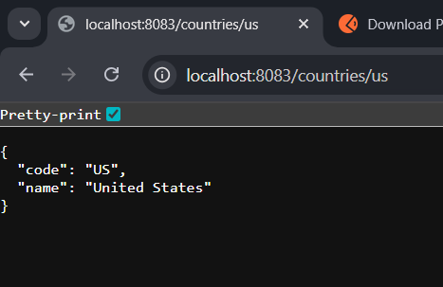  
  
IN:  
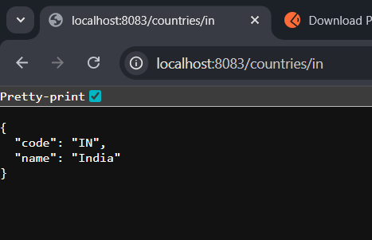**

**Console Log:**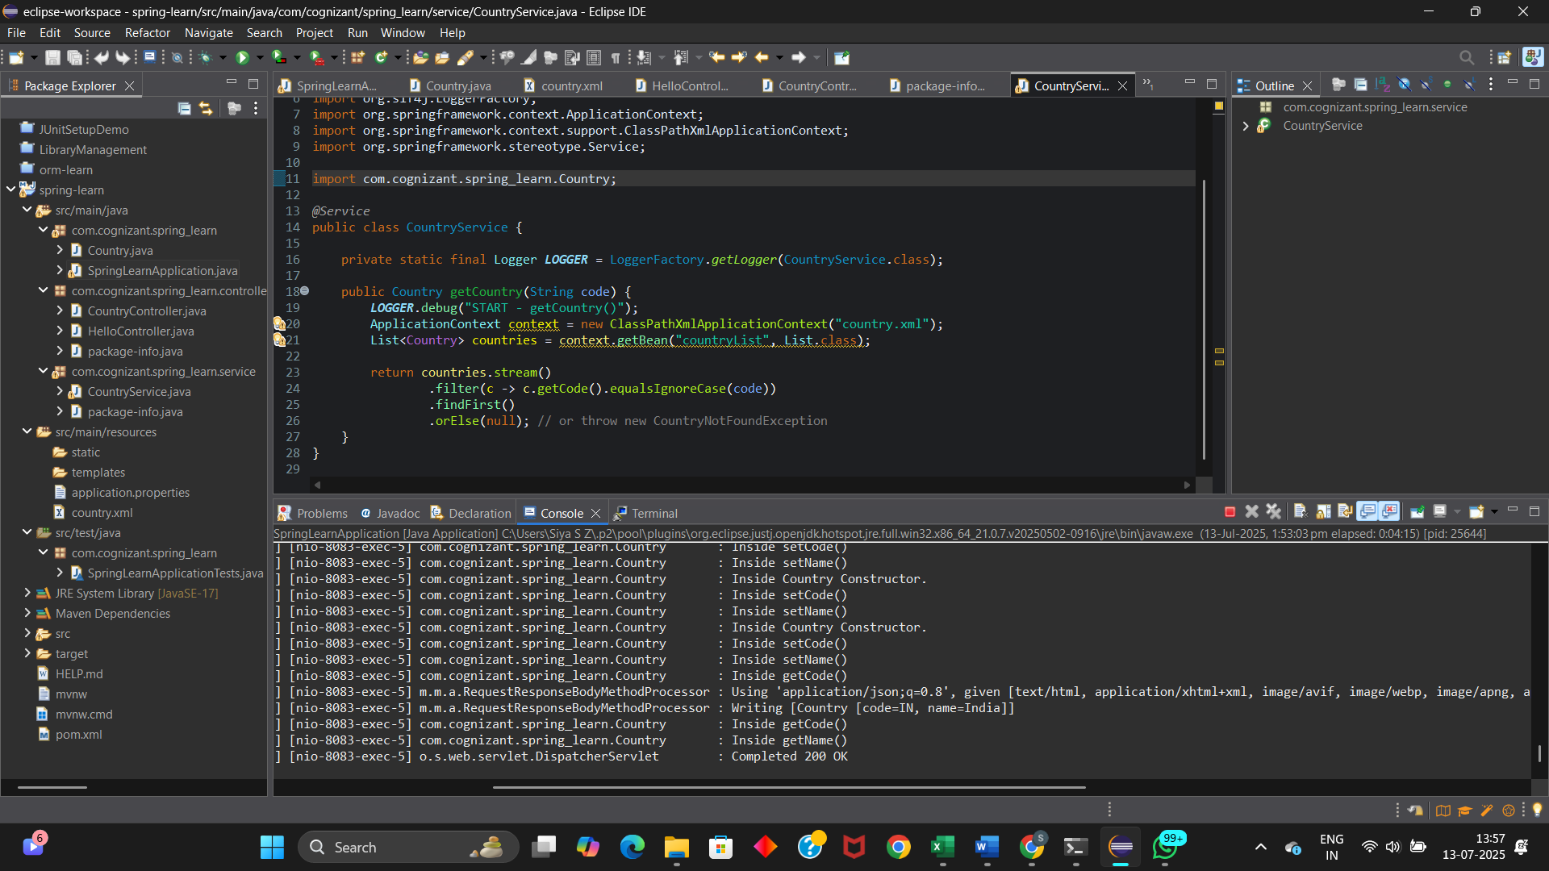

**JWT- HANDSON  
EXERCISE 6: Create authentication service that returns JWT**

**RESULT:**

**(ran into an error)**